2.1 Simulate a small network with switches and multiple devices. Use ping to generate traffic and observe the MAC address table of the switch. Capture packets using Wireshark to analyze Ethernet frames and MAC addressing.
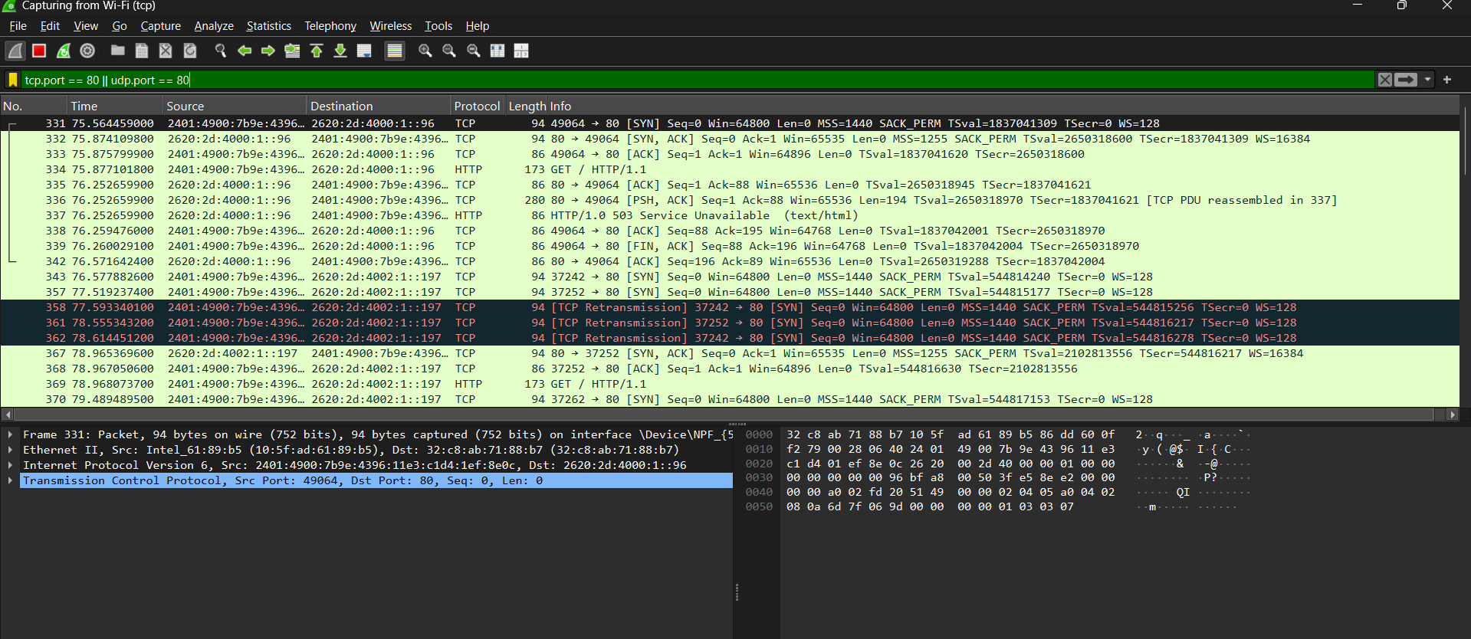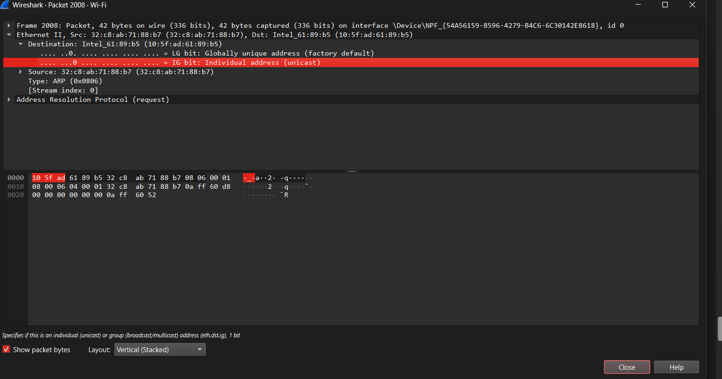
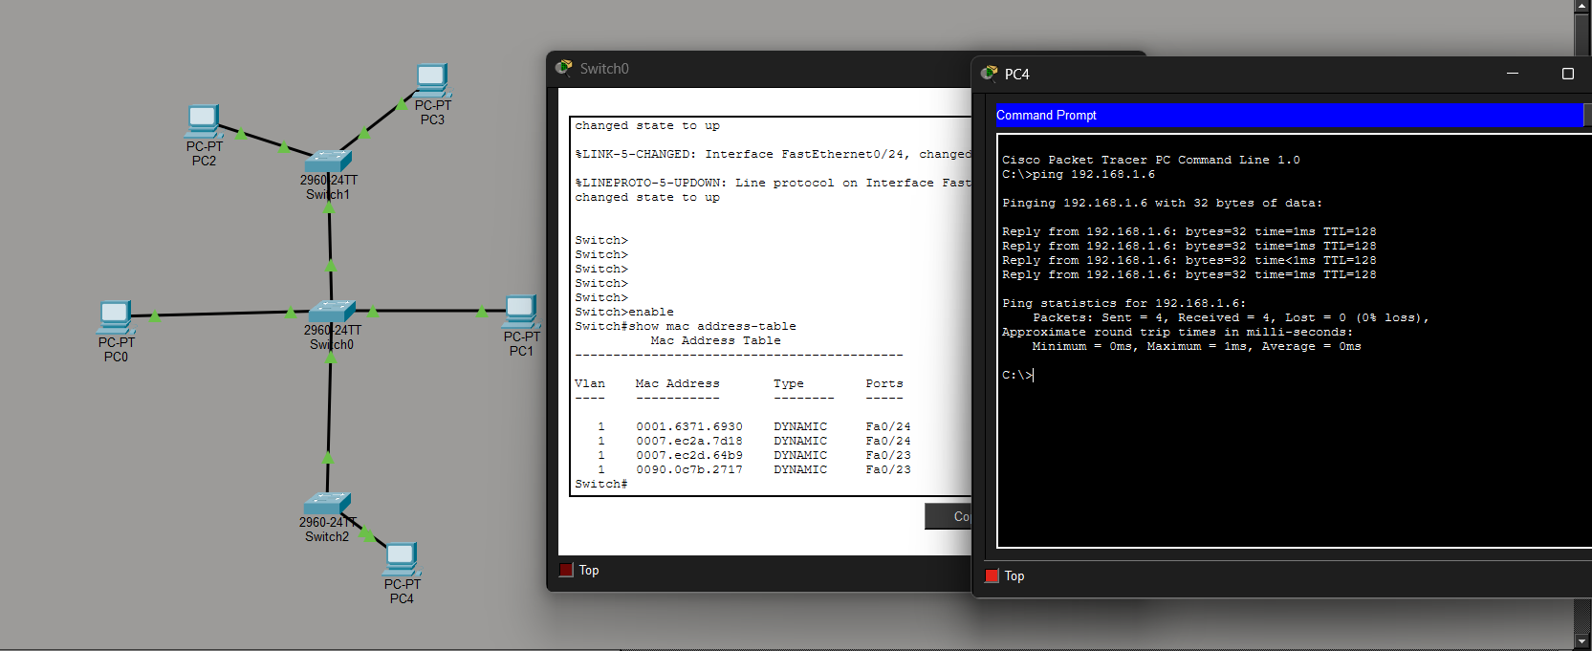
2.2 Capture and analyze Ethernet frames using Wireshark. Inspect the structure of the frame, including destination and source MAC addresses, Ethertype, payload, and FCS. Use GNS3 or Packet Tracer to simulate network traffic.
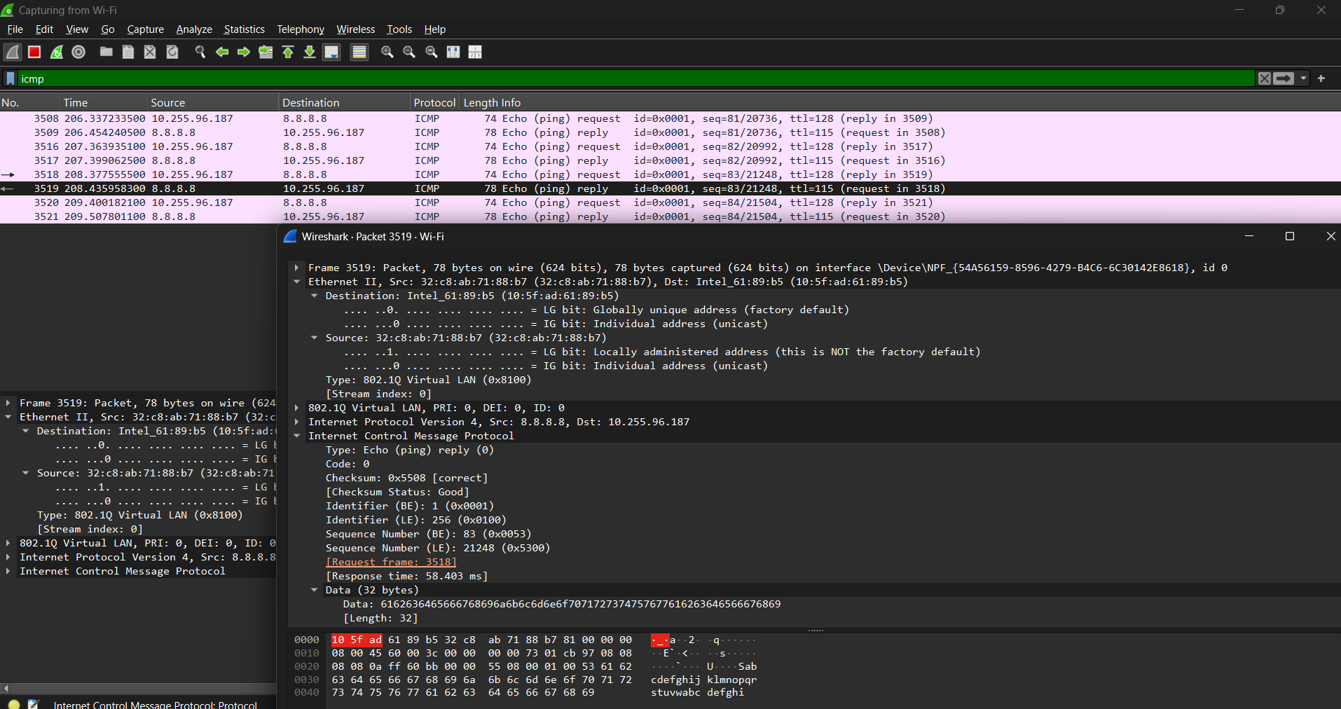

2.3 Configure static IP addresses, modify MAC addresses, and verify network connectivity using ping and ifconfig commands.
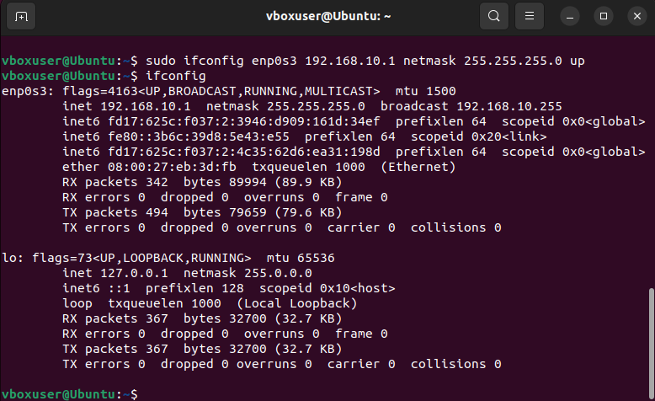
2.4 Troubleshoot Ethernet Communication with ping and traceroute -> Using cisco packettracer:
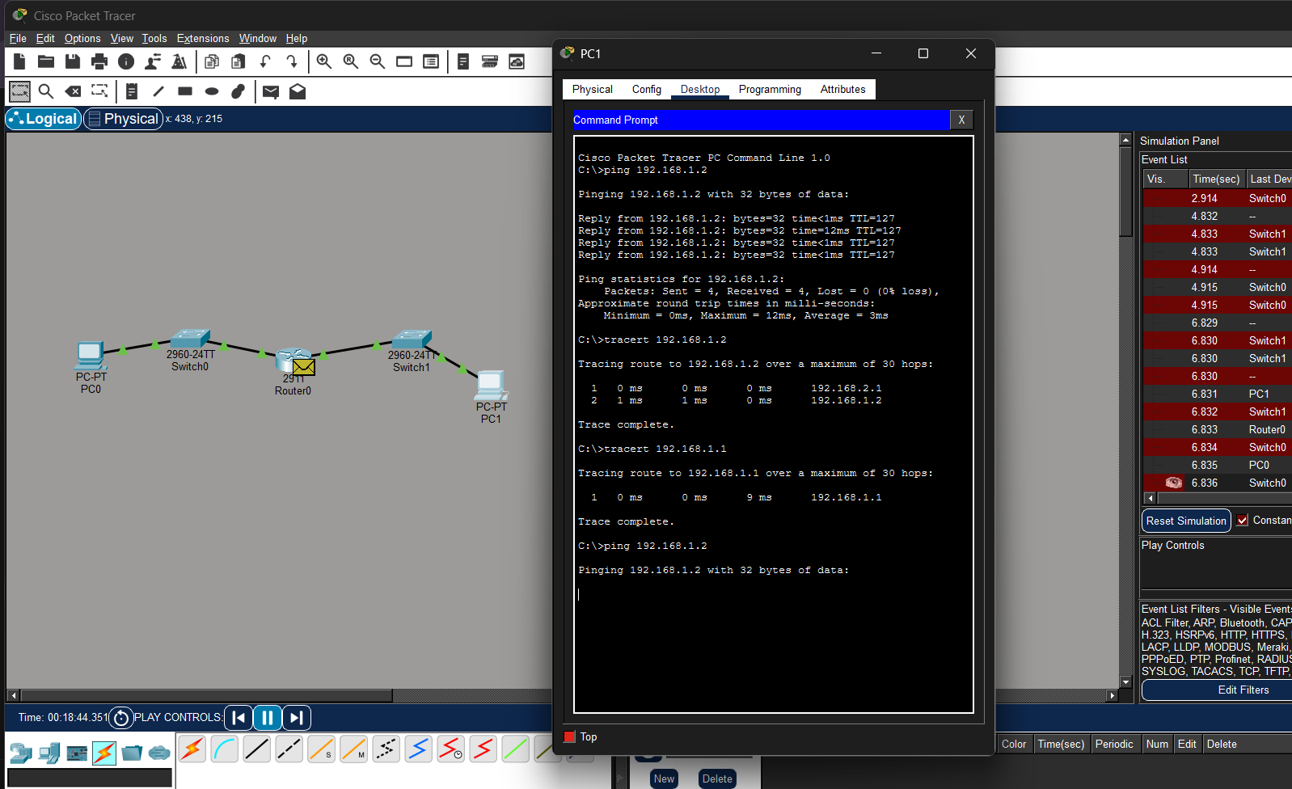

2.5 Create a simple LAN setup with two Linux machines connected via a switch.
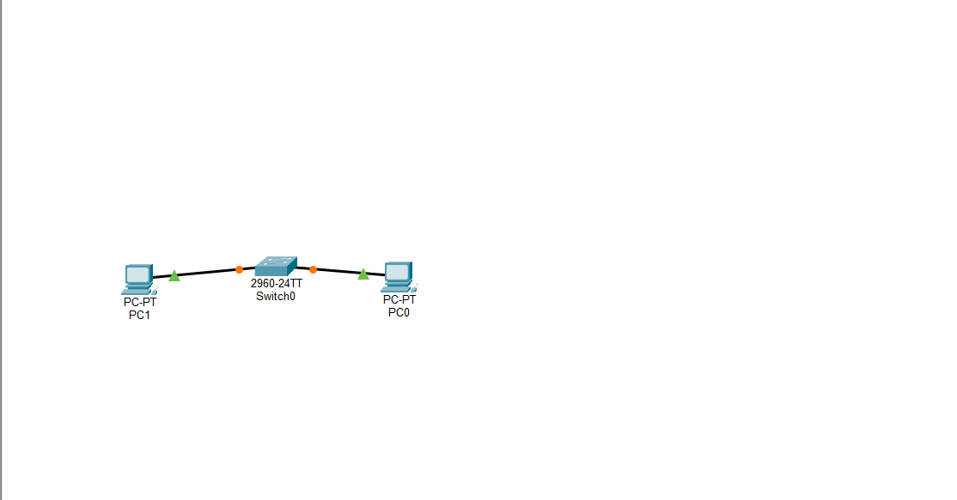
Ping from one machine to the other. If it fails, use ifconfig to ensure the IP addresses are configured correctly.
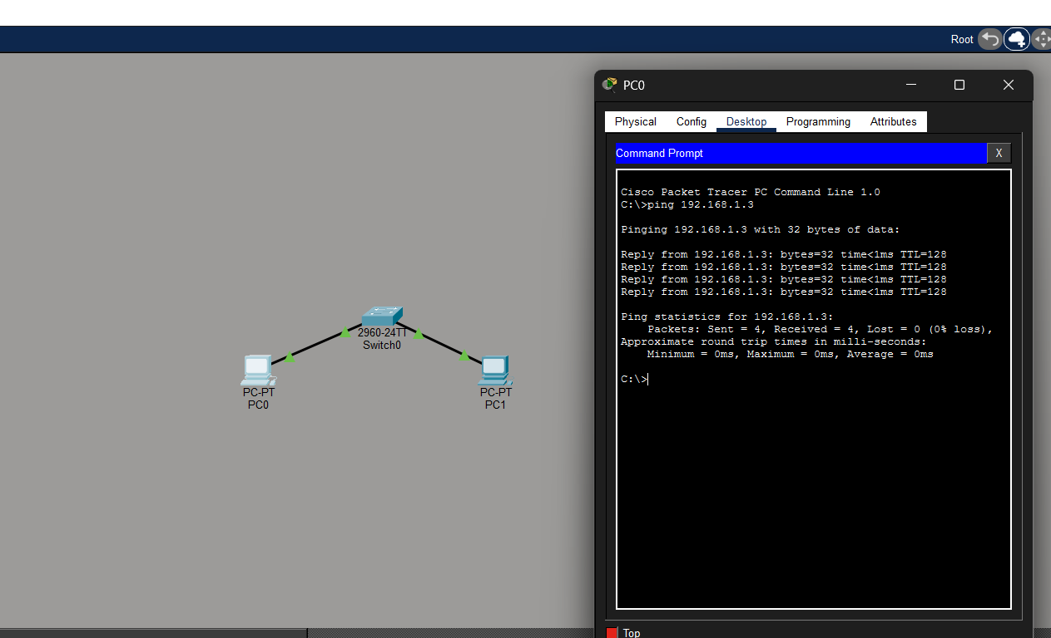
Use traceroute to identify where the packets are being dropped if the ping fails.
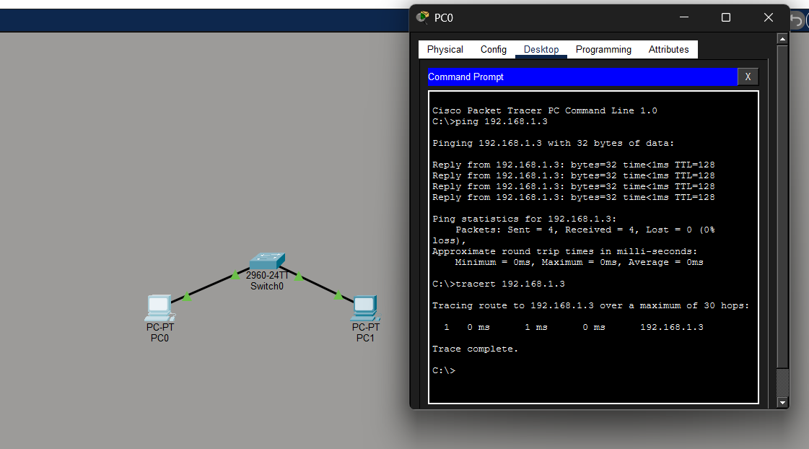
2.8 Research the Linux kernel's handling of Ethernet devices and network interfaces. Write a short report on how the Linux kernel supports Ethernet communication (referencing kernel.org documentation).
The Linux kernel handles Ethernet communication through its network stack and device abstraction. Each network interface is represented by a struct net_device, which stores details like the MAC address, MTU, and operations.
Ethernet drivers manage hardware interaction, handling frame transmission and reception via socket buffers (sk_buff). Incoming frames trigger interrupts; outgoing frames are queued and sent through the driver.
The networking stack processes frames with protocols like ARP, IP, TCP/UDP, and supports features like VLANs, bridging, and traffic control. User-space tools access interfaces via commands like ip/ifconfig or through Netlink sockets and sysfs entries.
In summary, Linux abstracts Ethernet hardware, delegates low-level operations to drivers, and integrates frames into its protocol stack, enabling efficient and flexible networking.

2.9 Describe how you would configure a basic LAN interface using the ip command in Linux (kernel.org).
Configuring a LAN Interface with ip in Linux
- Show interfaces:
ip link show
- Bring interface up:
sudo ip link set eth0 up
- Assign static IP:
sudo ip addr add 192.168.1.10/24 dev eth0
- Set default gateway:
sudo ip route add default via 192.168.1.1
- Verify and test:
ip addr show eth0
ping 192.168.1.1

2.10 Use Linux to view the MAC address table of a switch (if using a Linux-based network switch).
Use the bridge or ip link commands to inspect the MAC table and demonstrate a basic switch's operation.
Create switch:
sudo ip link add name br0 type bridge
sudo ip link set br0 up
sudo ip link add veth1 type veth peer name veth2
sudo ip link add veth3 type veth peer name veth4
sudo ip link set veth1 master br0
sudo ip link set veth3 master br0
sudo ip link set veth1 up
sudo ip link set veth2 up
sudo ip link set veth3 up
sudo ip link set veth4 up
sudo ip addr add 192.168.1.10/24 dev veth2
sudo ip addr add 192.168.1.20/24 dev veth4

ping -c 3 192.168.1.20
bridge fdb show

Device sends frame
Bridge reads source MAC
Stores in MAC table
Uses table to forward packets 